ASSIGNMENT 1

Part 1

Tran Thanh Minh

103809048

COS10026 – COMPUTER TECHNOLOGY INQUIRY PROJECT

Swinburne University of Technology

# Introduction

## Introduction

In recent years, because of Covid-19, the increasing demand for playing games at home. As the result, there are more created gaming websites, which are user-friendly and well-designed to attract players. In this report, I will discuss the process of designing and coding websites from a game topic. I will also include the techniques for designing and coding it and inform information about how to create an engaging website experience.

## Objective of report

The report is written to inform the readers about the websites and their features of the websites. I will explore the design considerations, user experience, technical requirements, and content creation necessary for a successful gaming website and also meet the requirements of the assignment. When all the members in my group participated to create it from HTML and CSS.

The report is also documented for the reader to understand the structure of the HTML file and also the CSS code.

## Outline

Introduction 2

Introduction 2

Objective of report 2

Outline 3

Website Content 4

Website pages 4

Home 4

Product 4

Enquiry 5

About 5

Enhancements 5

Sitemap 6

Website Style 7

Homepage 7

Product 8

Enquiry 10

About 11

Enhancement 12

Key Features 14

Contribution 15

Conclusion 16

Appendix 17

# Website Content

## Website pages

### Home

The Home page is named index.html which is also a Landing page where the user can see the topic and the theme of our websites (Game). This page also helps the readers to get visualization about our product.

In the file index.html, my teammate used the header for the navigation bar and also to make it meet the requirements of the assignment. He has followed my instruction by using a lot of div tags with the related-name class such as home-body, home-container … so that it won’t be messed up with other pages when we combine all the CSS. For any tag and elements that will be used among the other 4 pages, the class name of them also be named for use easily such as fixedtop, navbar-ul, … He has used a lot of div tags to adjust the location of the items, and contents for his webpage with unique class names. He has used the div tag effectively and naming the class easy to be called and with comments for maintenance easier. I saw he has used the button tags to increase the interactivity of the webpage with the users and assign them unique id names to modify it. For the footer part, he has used 3 different contents, quite like the lab activity to implement into the project to display essential contents.

### Product

This page mainly displays information about the displayed game so that the user can know more about popular games nowadays. If they have questions about the game, they can go to the Enquiry page. The users can see a lot of information about the games such as name, genre, …

In the product.html file, my teammate has used the five biggest tags to contain the content: div.fixedtop for the navigation bar, section.heading for displaying the header texts, section.game-list for displaying the content of games and their description, aside.aside-table for displaying the aside table for system requirements and div.footer-main for modifying the footer section within this product.html file only. For the three displayed products, he used div.game-card carefully and put the suitable contents and their description with the relative links to the subfolder images for the products’ images. In addition, he also has implemented the same requirements by assigning the alternative text that will be displayed when the image cannot load. He also created the button for the original link to where he found the image. His work has met all the requirements for assignment part 1 and he has used them in a great way when he used the order list, unordered list, and table within the aside and try to make the page easier to see in the simple but still give the users the luxury feeling.

### Enquiry

This is the page where the client can go to fill out the form and ask about the game if they want more information. The user can leave their personal information here so we can know what questions they are wondering about later. The main content is just the form, but the client needs to fill out all the fields except the comment field so that the form can be submitted.

I am the one who codes the Enquiry page. I have used the same navbar with others I have comments in my enquiry.html for each important part for easier maintenance. I have used the structure of block with the related class name for easier to identify such as block, half-row, and box,… I also implemented the patterns, and max length same as the requirements so that the users can enter the information correctly and return to the server without any missing information. For the checkbox, I have implemented the code quite different from the lecture and facilitator meeting so that I can implement the effect for it to contrast with the background color and make it with the effect for enhancing the user experience. I also have cited the button I have taken the animation effect from the third party.

### About

This page will only be about information about the team members in our group (Hobbies and timetable). So, the reader can understand and know about the demographic of each member.

In the about.html, my teammate has combined the section, figure, div, and dl tags to meet the requirements of the assignments. He has used the figure tag to display the members’ images and use the figcaption tag for members’ names. The definition tag is used for the demographic information of members such as age, and gender … In addition, the interest list is also implemented for the interests of each member. He also included the timetables for each member of the group for making the About page more descriptive about each member.

### Enhancements

This page will describe the enhancements we have included in our websites and how have we implemented them. We also include the hyperlink to the webpage where we apply the enhancements.

In this enhancements.html file, my teammate has imported some icons which were taken from Flaticon website to make the animated background to enhance the user experience. He also used the div tag for linking the headers of each enhancement to the page where the enhancement features were implemented. A lot of span tags were used to make the important words become easier to be seen. The lecturers and other readers can know about important tags that can be used to create these enhancement features. He also has cited the link to where he took the effect and implemented it into the page.

## Sitemap

*Image 1: Sitemap for the project*

# Website Style

## Homepage

*Image* *2: Home page(index.html)*

For the navigation bar, to make its animation when we resize the window, my group has to add the transition ease in out for the HTML tag and also add the overflow-x hidden to make all the extended-window content hidden. With the use of pseudo-class and element, I have made the hover effect for the navigation bar give the feeling of gaming. I have downloaded the font into the CSS folder so whenever we call the “future” font, the gaming font will be applied. I use this font to enhance the attractiveness of our web pages. The image of characters and cubes are used for the background image which also has some animations of moving when resizing the window to make the resizable content smoother when resizing.

My teammate also used the @media query for ensuring the flow of the websites will be displayed correctly on different devices (for tablets and phones) for reaching users worldwide, no matter what devices they are using to suffer through these webpages. He has implemented simple animations for almost entire of the content on the Home Page so that when the window is resized or the users interact with the webpage, they can see how smooth it is.

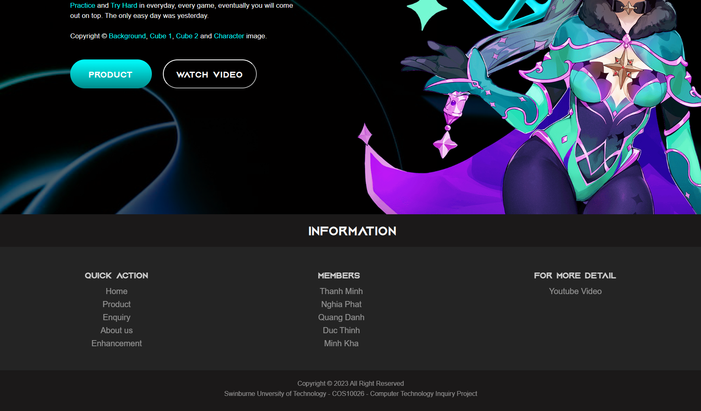

*Image 3: Footer of Home page*

## Product

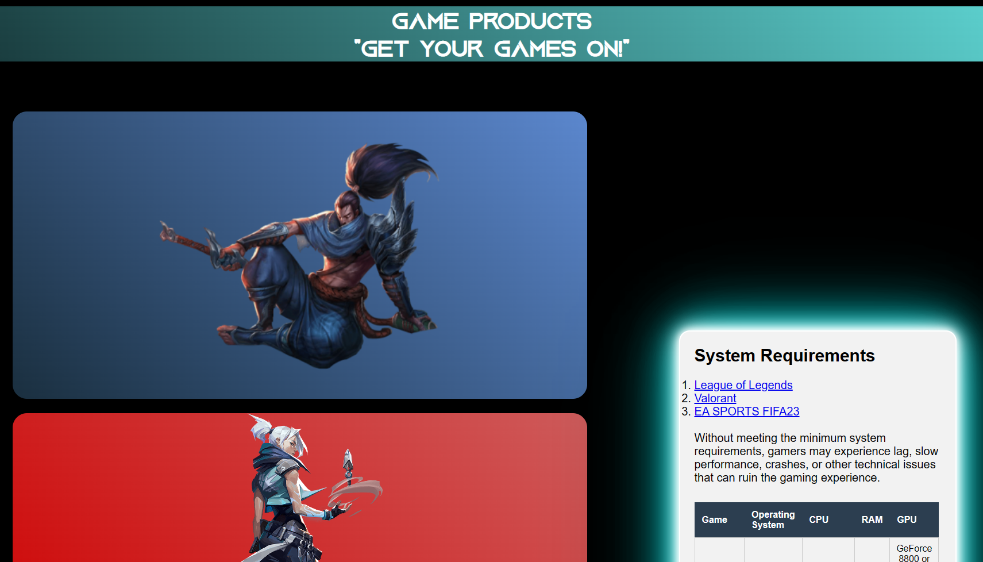

*Image 4: Product page (product.html)*

There is one enhancement that our group has chosen to implement into this website, which is the image’s hover effect. Whenever the users hover over the product image, detailed information and description will be displayed. Additionally, if the users want to enquire about the product, there will be a direct button leading them to the Enquiry page. There is another button that my teammate used for citing the image. My teammate has applied the left justify-content and center align items for each of the cards of the product. With the use of a suitable font for headings and descriptions, he has successfully for implementing the gaming style into this website when the reader still can read the description clearly with the sans-serif font and is impressed by the name of the product in font “future”.

Because our group apply the background color black for the universal sign so there are a lot of transparent background properties for removing the black background and making the content contrast with the background. Lastly, for the small display screen such as smartphones, aside content will display incorrectly so my teammate has pushed it down below the products. After the users have viewed all the products, they can view the system requirements for a suitable device for playing games.

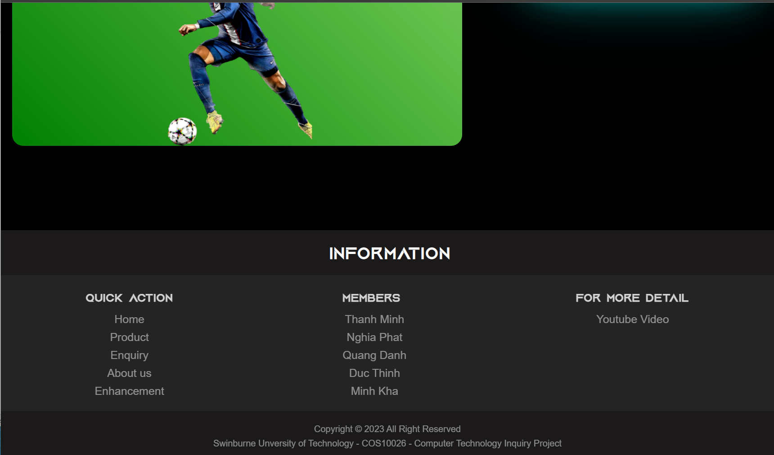

*Image 5: Footer of the Product page*

## Enquiry

*Image 6: Enquiry page (enquiry.html)*

For my work of coding the Enquiry page, I have styled the div tags to display flex and use flex-wrap when resizing the window. When the users use the laptop for big screen display, there will be two columns, but if they use a smaller screen display such as their smartphones, there will be only one column of content. For the labels, I have used my imported font “future” for giving the gaming experience.

I also have used a lot of class and id for many elements, for styling it correctly so that it won’t display incorrectly when the users view the pages in different sizes of screen. I also used black, white, and cyan color to enhance the color contrast so that the users can be impressed by the style of the website.

I also have implemented some small animations and features to make the websites can be more interactive a little bit by adding the moving outline border for contents in the fieldset, the checkbox color and submit button effect.

*Image 7: Remain part of the Enquiry page.*

## About

*Image 8: About page (about.html)*

He has implemented the hover effects for combining pseudo-class and hover for the image so that when the users hover over the image, the detailed information will be displayed. His CSS code also meets a lot of requirements in the assignments such as a figure with a double border, and table cell background color using hexadecimal, … Although, he hasn’t known how to minimize the code so there are some unnecessary code or code has similarities but isn’t grouped for better maintenance.

When the window is resized for small screen display, all the margin-top of the description will be increased so that the image will be displayed before the description and demographic of each member.

## Enhancement

*Image 9: Enhancement Page (enhancements.html)*

My teammate has used a lot of class and id names for creating animations for every single imported icon to make the page more attractive. Decreasing CSS code is necessary for the page to load faster, and he has done a great job in this field where he groups all the similarities of tags, elements, ids, and classes to make effects.

He has been excellent in using color contrast to make the content become contrast with the background so that the viewers can see the content.

*Image 10: footer of Enhancement Page*

# Key Features

The gaming website's design incorporates several innovative features and improvements to provide an amazing user experience. The usage of CSS animations to enhance the website's visual appeal and user experience is one of its most notable characteristics. In particular, the product page has been improved with CSS elements to make it more dynamic and user-friendly. The layout of both the product and about us pages is well-organized, making them simple to use and navigate. On the other side, the landing page was designed, with a contrasting color palette that emphasizes the web site’s gaming aspect. All of these additions and features have been thoughtfully designed to make the website stand out and offer users a remarkable experience.

For the Home page, my teammate has created some simple animations for the gaming characters when resizing the window so that our web pages can improve the user experience when users suffer to see the content of our webpages. My teammate also created small animations on the box around the characters to make the users when entering the landing page, they can be surprised by the contents and the quality of the animations. The navbar also is animated when resizing the window, my teammate has made it from a bug become an interesting feature.

For the Product page, although there are a few products displayed my teammate has enhanced the user experience by making the hover effects for each of the products into the gaming style to attract the users.

For the Enquiry page, I have tried to improve the user experience by making the content lighter with cyan color. I also apply a CSS animation to the submit button to make it turn into a gaming style. I also add some cyan border color to make the form become prettier with the theme quite like the space theme with darkness and cyan color.

For the About page, the effect is simple than another webpage where the users can hover over the image to see the demographic and information of each member who has contributed to this web page.

Lastly, the Enhancement describes the effects of the other two enhancements that we have included in our web pages. This page has an animated background with images of the gaming icons to give the users the feeling of suffering through a game instead of a webpage.

# Contribution

Throughout the process of developing the websites, I have made valuable contributions to the project of creating gaming websites from HTML and CSS. I have taken an active role when organizing the team’s work, understanding other strengths and their wants so that I can give them a suitable amount of work. I also ensure that everyone has suitable resources to go through and base on it to build up the website and complete their tasks. Additionally, I have played a key role in designing the process when engaging others to design the websites before starting to code directly. I show them the basic techniques of how to use Adobe XD to create the mock-up. For my part, I have used Adobe XD to create the Enquiry and Home pages.

My contribution also extends to the technical side of the project. I have done my part earlier than others a lot which is done the Enquiry page and navigation bar. I also contributed to everyone’s process of coding, so I understand almost all their work and their features so that in many circumstances, I have feedback for them directly when they are coding or struggling. Additionally, I also involve in the process of combining all the CSS code when I supported the one who collect all the code together and instruct him to do the right actions so that the code don’t mess up or affect other pages. I’m also one of two members in the group responsible for fixing errors and trying to reduce the errors of others’ code, I have been involved in creating the about.html because my teammate hasn’t done the expected quality of work so I have to redo almost entire the About page.

I am also the one who asks the lecturer the most when I want to ensure all the work of my teammate has met the requirements and extends beyond what I have expected. Understanding the requirement of the assignment is the key thing before starting to do any part of the project because it can minimize the unnecessary time for fixing bugs or misunderstanding work.

After I have finished my work, I help others to identify suitable enhancements to use for the websites. I also remind others about the deadlines regularly and assist my team members who are struggling with coding and designing the websites. I also involve in the process of checking whether others have done the work the same as the requirements or not so that my group’s points won’t be reduced by minor mistakes. Whenever someone has submitted the work, I will check their code against the rubrics so that I can feedback on their work, and they can fix it as soon as possible for not to extend the deadlines. I try to make their engagement go beyond what they must to make the team succeed. Throughout the first part of the project, I feel like I am the leader who drives the team to success and make the first part complete.

# Conclusion

Based on the innovative features and enhancements that were highlighted throughout this report, I have shown evidence that both I and my teammates have put a lot of effort and attention to create an attractive and user-friendly gaming website. It also was implemented with several unique features to boost the user’s experience, including the use of CSS animations to make it more attractive. Especially, the product page was created to provide the user experience and information about the game. The Product page and the About page were created with a good structure layout and ease to use.

To enhance the website so that it can go beyond other gaming websites, future enhancements could be included to have more interactivity… Additionally, responsive design for mobile users was implemented to reach wider users worldwide if the websites were published.

In conclusion, this first part of the project has been a success for me and the other members. The website has been designed based on the user’s experience criteria. By continuing to implement more enhancements and features in the future, this website would attract a lot of visitors which are including users, and others who want the taste of a good website, providing useful information for gamers.

# Appendix

**Sitemap**

**Adobe XD design mock-up**

<https://xd.adobe.com/view/7a06e7bf-9958-4884-8528-16234a871433-2f55/>

**Link to website**

[Link](https://se7en-cos10026.netlify.app/)

[Link to mercury](https://mercury.swin.edu.au/cos10026/s103809048/assign1/index.html)